Project Design Phase-II
Data Flow Diagram & User Stories
Date | 24 September 2026
Team ID | SWTID-2026-7356
Project Name | AI StudyBuddy
Maximum Marks | 4 Marks
Data Flow Diagrams:
The data flow diagrams below are based on the implemented AI StudyBuddy backend. They show how data moves between students and administrators, authentication, study-material management, AI processing with Gemini 2.5 Flash, and MongoDB storage.
DFD Level 0
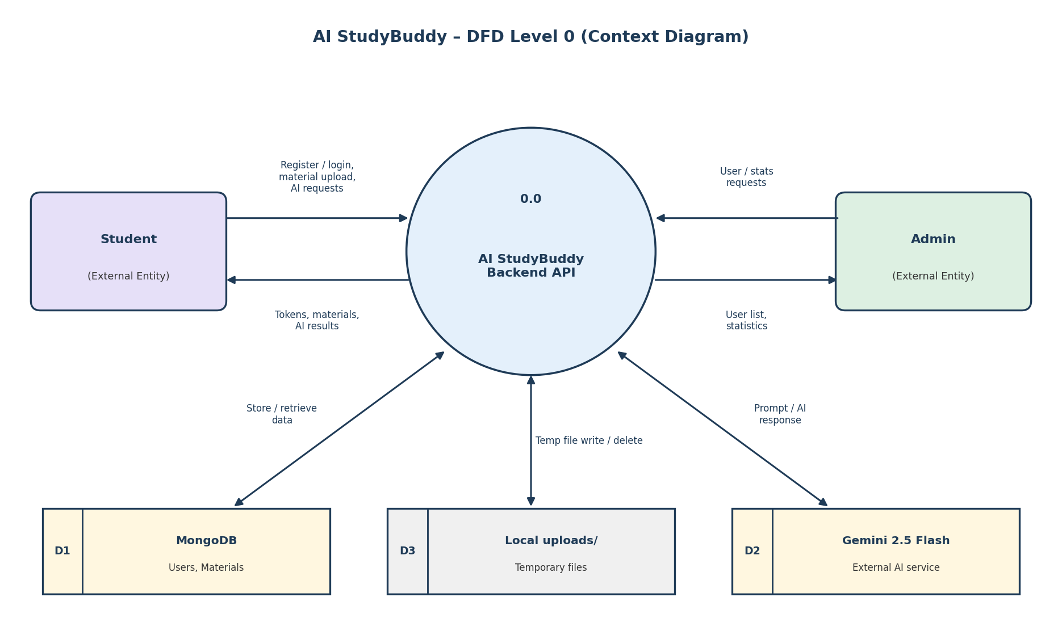
Figure 1: DFD Level 0 – System Context Diagram
DFD Level 1
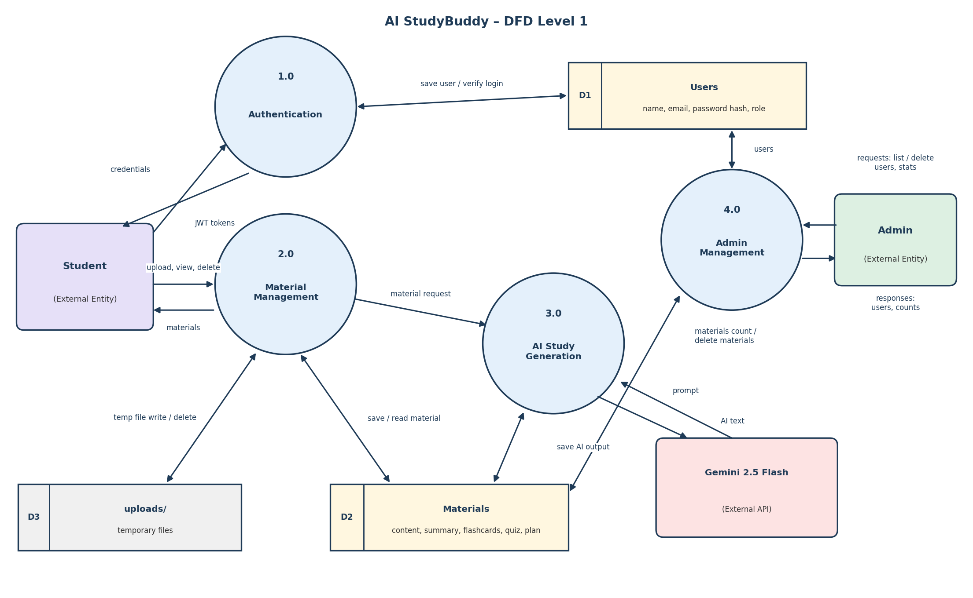
Figure 2: DFD Level 1 – Authentication, Material Management, AI Study Generation and Admin Management
User Stories
The user stories below are drawn from the implemented AI StudyBuddy API. They cover authentication, study-material management, AI-powered study features and administrator functions.
User Type | Functional Requirement (Epic) | User Story Number | User Story / Task | Acceptance criteria | Priority | Release
Student | Registration | USN-1 | As a student, I can create an account by entering my name, email, password and, optionally, a role. | A new user account is created and access and refresh tokens are returned. A duplicate email is rejected. | High | Sprint-1
Student | Login | USN-2 | As a student, I can sign in with my email and password. | Correct credentials return access and refresh tokens; incorrect credentials are rejected. | High | Sprint-1
Student | Authentication | USN-3 | As a student, I can renew my access token using my refresh token. | A valid refresh token, sent in the x-refresh-token header, returns a new access token and refresh token. | High | Sprint-1
Student | Logout | USN-4 | As a student, I can sign out of the application. | The logout endpoint returns a success response, and the client discards its stored tokens. | Medium | Sprint-1
Student | Study Material | USN-5 | As a student, I can upload a study file and give it an optional title. | A .txt, .md or .pdf file up to 5 MB is accepted and saved as a material; any other file type is rejected. | High | Sprint-1
Student | Study Material | USN-6 | As a student, I can see a list of my uploaded study materials. | Only the student's own materials are listed, without the content, flashcards, quiz or study plan fields. | High | Sprint-1
Student | Study Material | USN-7 | As a student, I can open one of my study materials. | The material is shown if it belongs to the student; otherwise access is denied. | High | Sprint-1
Student | Study Material | USN-8 | As a student, I can remove a study material I uploaded. | The selected material is deleted, and materials of other students cannot be deleted. | Medium | Sprint-1
Student | AI Summary | USN-9 | As a student, I can create an AI summary of my study material. | Gemini produces a short bullet-point summary, which is saved with the material. | High | Sprint-2
Student | AI Flashcards | USN-10 | As a student, I can create AI flashcards from my study material. | The requested number of question-and-answer flashcards is generated, saved and returned. | High | Sprint-2
Student | AI Quiz | USN-11 | As a student, I can create an AI multiple-choice quiz from my study material. | Multiple-choice questions with options and answers are generated, saved and returned. | High | Sprint-2
Student | AI Study Plan | USN-12 | As a student, I can get a personalised study plan by giving my goal, daily study hours and number of days. | Gemini returns a day-by-day schedule based on the material and the preferences provided. | High | Sprint-2
Administrator | User Management | USN-13 | As an administrator, I can see all registered users. | A protected admin endpoint returns the list of users without their passwords. | Medium | Sprint-2
Administrator | User Management | USN-14 | As an administrator, I can remove a user. | The selected user and all materials owned by that user are deleted. | Medium | Sprint-2
Administrator | Dashboard / Statistics | USN-15 | As an administrator, I can see the total number of students and study materials. | The system returns the current counts of student users and study materials. | Medium | Sprint-2

